**Project Development Phase Model Performance Test**

|  |  |
| --- | --- |
| Date | 10 November 2022 |
| Team ID | PNT2022TMID44074 |
| Project Name | Project – WEB PHISHING DETECTION |
| Maximum Marks | 10 Marks |

**Model Performance Testing:**

Project team shall fill the following information in model performance testing template.

|  |  |  |  |
| --- | --- | --- | --- |
| **S.No**  **.** | **Parameter** | **Values** | **Screenshot** |
| 1. | Metrics | **Classification Model:** Confusion Matrix - , Accuracy Score- & Classification Report - |  |
| 2. | Tune the Model | Hyperparameter Tuning - |  |



**1. Metrics**

**Classification Model:** Confusion Matrix - , Accuracy Score- & Classification Report -

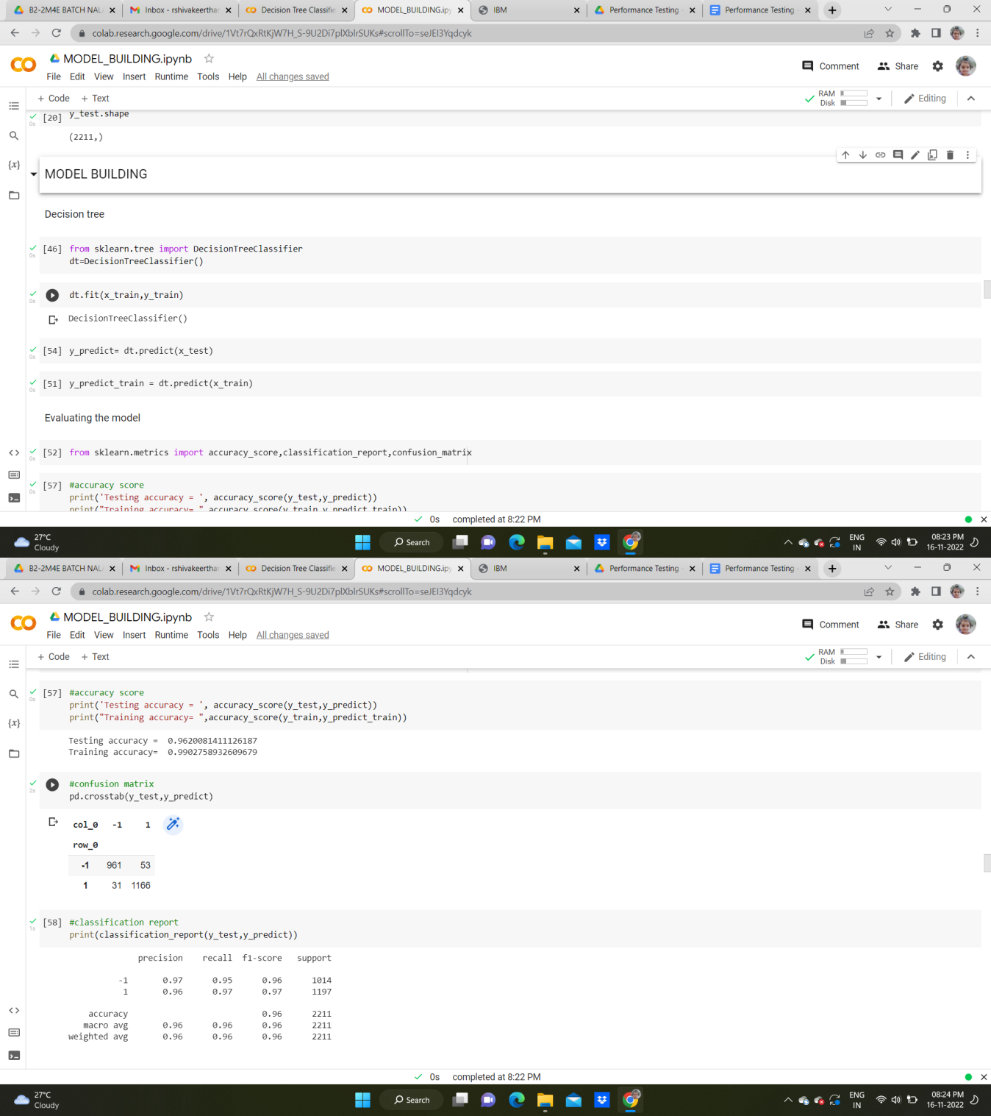



Only two pages were converted.

Please **Sign Up** to convert the full document.

[**www.freepdfconvert.com/membership**](https://www.freepdfconvert.com/membership)